Automated Waste Management : Waste Collection Enhanced By Autonomous Navigation and Urban Household Integration.

Mithilesh K   
*Department Of Electronics and Communication*  
*Amrita Vishwa Vidyapeetham*Coimbatore, India  
CB.EN.U4CCE21034

Pubesh Kumaar KS  
*Department Of Electronics and Communication*  
*Amrita Vishwa Vidyapeetham*Coimbatore, India  
CB.EN.U4CCE21048 Hari Krishna N   
*Department Of Electronics and Communication*  
*Amrita Vishwa Vidyapeetham*Coimbatore, India  
CB.EN.U4CCE21036

Rakesh V  
*Department of Electronics and Communication*  
*Amrita Vishwa Vidyapeetham*Coimbatore, India  
CB.EN.U4CCE21051

*Abstract*—This project presents the implementation and integration of a sensor integrated autonomous line following robot for precise and efficient waste collection and management. Leveraging the amazing capabilities of different sensor technologies, inclusive of Infrared (IR) Sesnors for line detection and navigation, Ultrasonic Sensors for obstacle and level sensing, Color Sensor for targeted house to house waste collection. Additionally, usage of dual H-bridge L298N for navigation of dc motors allows their seamless movement and the integration of toggle switch-based reflector system within households enables residents to call for waste collection requests as and when required. Through this innovative strategy the project aims to optimize waste collection and revolutionize waste management in urban areas by reducing need for human intervention ensuring timely and efficient waste collection.

Keywords — Sensor Technologies, Autonomous Navigation, L298N, Toggle-Reflector-System, Household Integration, House to House Waste Collection, Reducing Human Intervention, Efficient Waste Collection.

# Introduction

With an increasing world population and fast paced immigration to urban areas driven by after effects of rapid industrialization and urbanization waste management becomes a central issue in such cases. Improper [1] waste management leads to several issues ranging from cholera, typhoid to dysentery, plague etc.

In India the existing waste collection process in cities is handled by municipal corporation authorities where in periodic collection of garbage is overseen and handled. This process however is very [2] much labour intensive, prone to human errors and delays leading to several inefficiencies as waste collection schedule may not align with waste generation patterns.

The emergence of fourth industrial revolution has led to unparalleled advancements in various fields cutting across from agriculture to military with a correct integration and usage of Artificial Intelligence, Sensor technologies, Robotics and Internet Of Things (IOT). These automation processes have benefited different kinds of industry from optimizing their cost to efficiently increasing production quantity. By utilizing these automation technologies it is possible to enhance, optimize the processes of waste management and collection.

In this context our proposed project aims to automate and optimize the process of waste management by the virtue of Line Following Robot integrated with various sensor technologies enabling seamless navigation leveraging the advantages of IR sensor for line following and navigation, Ultrasonic Sensor for obstacle detection and level sensing and a Colour Sensor for house to house waste collection. The project also incorporates toggle-switch based reflector mechanism coupled with colour sensor enabling residents to raise requests as and when necessary and robot stopping whenever led glow is detected positioned in front of houses in colony. The integration of L298N dual H-bridge motor drivers immensely help in navigation and control of dc motors connected to robotic structure ensuring reliable optimized movement of structure.

Through this innovative strategy, our project aims to address the issues of increased labour cost, improper collection of garbage by automating the process ensuring optimized and efficient waste collection contributing to a cleaner environment with a healthy populace. This innovative modern approach is not just limited to addressing issues of waste management but also paves way for a more smarter and sustainable urban environment.

# LITERATURE SURVEY

To get data on latest research different papers on topic

was surveyed.

The authors Saranya S and Vigneshwaran S proposed a system which utilized help of an IR sensor for navigation where in the structure moves in a predefined path if and only if the IR sensor’s output is low [1]. An ultrasonic Sensor is utilized for obstacle detection placed at pinnacle of dustbin. The motor driver controls movement of DC motor and a smell sensor is also used here which detects amount of garbage dumped. If the output of smell Sensor exceeds a threshold the dustbin would automatically start moving to garbage dumping yard.

In the paper ‘A REAL-TIME AUTONOMOUS WASTE-COLLECTING ROBOT’ authors Pratheep Kumar V, Prabha KS, Prabhakar K, propose a system which uses the presence of ultrasonic sensor to detect possible obstacles in path. It moves according to the command given by the Arduino in which the line following coding is dumped. Two IR sensors are placed in the [2] front side of the robot, which absorbs the IR radiation from the black colored lines that is drawn down. A metal detector is a portable electronic instrument which detects the presence of metal nearby, if any metal is detected then it placed in bin1 and non-metal particles are placed in bin 2. Here L293D motor driver is used.

In the paper ‘FULLY AUTOMATED WASTE MANAGEMENT SYSTEM USING LINE FOLLOWER ROBOT’ authors Sampath Kr Ghosh, Shaikh Sahil Ahmed, Rohit Sunil Meshram, Geetha V, and Sanket Salvi propose a system driven by sensor integrated system to Arduino UNO [3]. A dual H-Bridge L293D is used to drive the motors two ultrasonic sensors are used here to monitor levels of dustbin and another for obstacle detection

# Proposed system

## COMPONENTS USED

ULTRASONIC SENSOR :

An Ultrasonic Sensor works based upon SONAR principle (Sound Navigation and Ranging) wherein transmitters in ultrasonic sensor exchange signals into ultrasound, receiver converts ultrasound onto signals.

In an ultrasonic sensor echo and trigger are key terms associated with its operation wherein the trigger signal initiates the emission of the ultrasonic pulse, while the echo signal is the reflected pulse detected by the sensor, used to calculate distance. The distance is calculated by

***Distance = (0.034*duration)/2***

(0.034 = Sound Velocity in micrometer/second, Distance = time required for sound waves to transmit and return)

It is also used for functionality of “*level sensing*” to detect amount of waste dumped in structure.

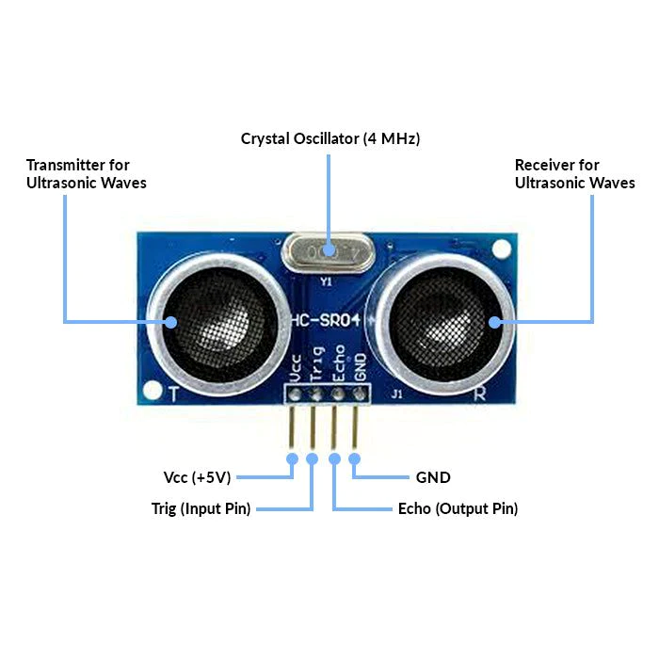

Figure 1 – ULTRASONIC SENSOR

ARDUINO MEGA:

Arduino Mega is a low-cost, flexible, and easy-to-use programmable open-source microcontroller board, here Arduino is interfaced with various sensor technologies including ultrasonic, infrared, Color sensor technologies and communication between transmitting and receiving devices.

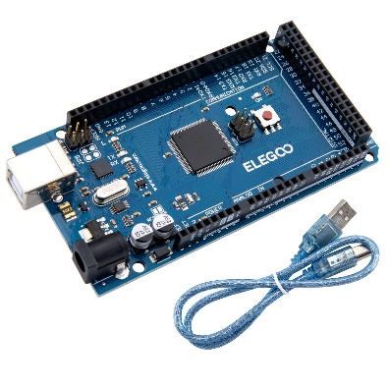

Figure 2 – ARDUINO MEGA

IR SENSOR :

IR sensor is a device which detects infrared radiation emitted by objects in the environment. IR sensor is used to sense the black and white surface. It is fixed to the frontside of the robot and helps in line following and navigation mechanism.

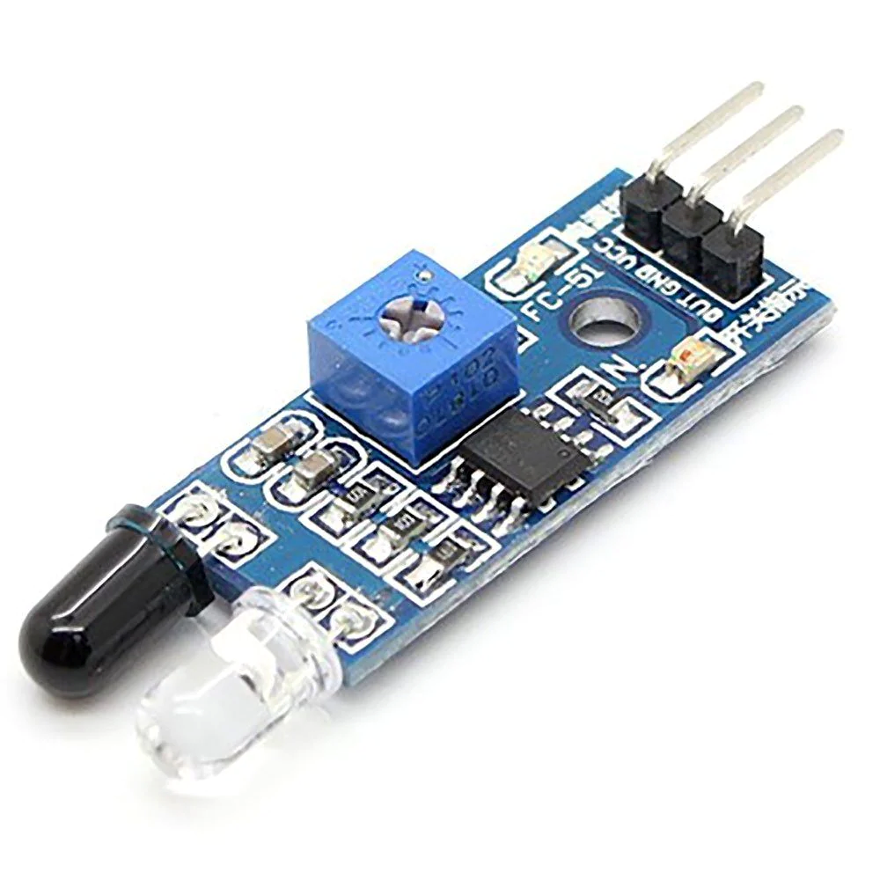

Figure 3 – INFRARED SENSOR

COLOR SENSOR :

The TCS3200 sensor can detect the intensity of light in red, green, blue, and clear channels, allowing it to determine the colour of an object. Here, within system colour sensor is used to recognise illumination of led (reflector) used as form of request from households and halting of structure after its recognition.

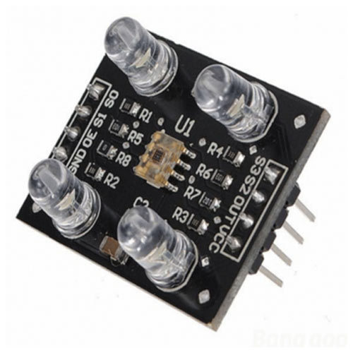

Figure 4 – TCS3200 COLOR SENSOR

DC MOTOR :

The conversion of Electric to Mechanical power is done using DC Motor. It works based on code given to Arduino board from Arduino IDE. 4 DC motors are used here for the movement of structure controlled by L298N motor driver.

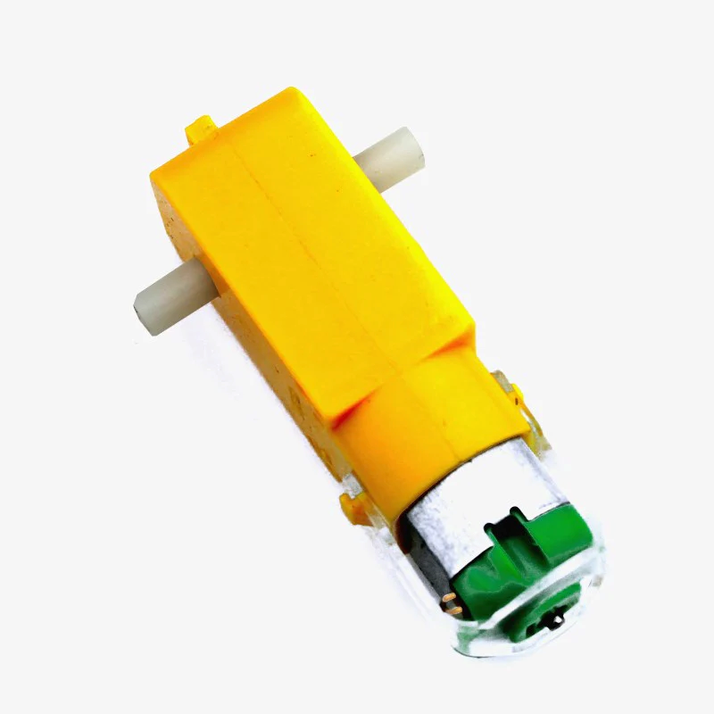

Figure 5 – DC MOTOR

L298N MOTOR DRIVER :

The L298N is a dual H-Bridge motor driver which allows us to control speed and direction of two DC motors at the same time. The module can drive DC motors that have voltages between 5 and 35V, with a peak current up to 2A.

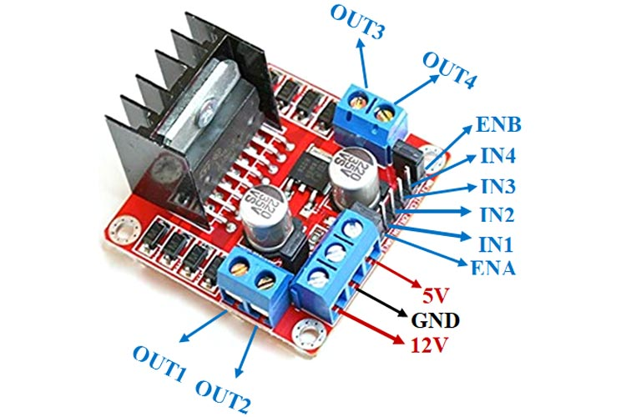

Figure 6 – L298N MOTOR DRIVER

Table 1 – COMPONENTS USED IN STRUCTURE

|  |  |  |
| --- | --- | --- |
| **Name** | **Features** | **Usage** |
| Arduino MEGA | The Arduino is microcontroller  board which is basically a system on a chip. | It is used for controlling the Waste Collection structure. |
| DC Motor | 12-volt DC Motor are used to rotate the wheels of the robot car whose speed is 300 RPM | It takes input from Micro-Controller and controls movement of Structure |
| L298N  Motor Driver | L298N is a 15 pin Integrated Circuit allows the DC motor to drive in both the direction in accordance with our requirements, it can control up to 4 motors at a time | It is used for controlling the DC Motor connected to Structure |
| TCS 3200 Color Sensor | The TCS3200 sensor can detect the intensity of light in red, green, blue, and clear channels. | It is fixed beneath the structure of robot helps in sensing the illumination of reflector in front of house which is raised as a form of request. |
| IR Sensor | Device that detects infrared radiation emitted in the environment. | It is used for identifying black line and helps in navigation the waste collection vehicle |
| Ultrasonic Sensor | Ultrasonic sensors use the ultrasonic waves for measuring the distance. | It is used to monitor the waste level in the waste bin as well as for detection of obstacle within path of navigation. |

## BLOCK DIAGRAM

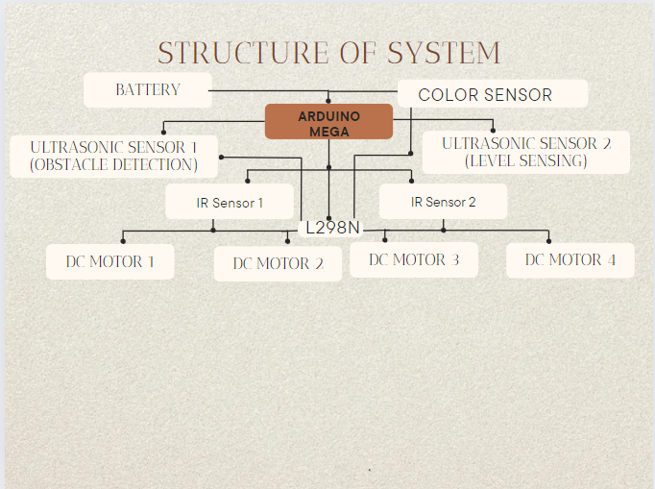

Figure 7 – BLOCK DIAGRAM OF SYSTEM

## WORKING CODE:

//color sensor initialization

int red = 0;

int green = 0;

int blue = 0;

#define IR_SENSOR_RIGHT 11

#define IR_SENSOR_LEFT 12

#define MOTOR_SPEED 150

const int TRIG_PIN = 30;

const int ECHO_PIN1 = 28;

const int LED_PIN = 22;

const int DISTANCE_THRESHOLD = 7;

float duration_us, distance_cm;

// Right motor

int enableRightMotor = 6;

int rightMotorPin1 = 7;

int rightMotorPin2 = 8;

// Left motor

int enableLeftMotor = 5;

int leftMotorPin1 = 9;

int leftMotorPin2 = 10;

// Ultrasonic sensor

#define TRIGGER_PIN 3

#define ECHO_PIN 4

#define MAX_DISTANCE 200 // Reduced maximum distance for testing

#include <NewPing.h>

NewPing sonar(TRIGGER_PIN, ECHO_PIN, MAX_DISTANCE); // NewPing setup of pins and maximum distance.

void stopMotors() {

digitalWrite(rightMotorPin1, LOW);

digitalWrite(rightMotorPin2, LOW);

digitalWrite(leftMotorPin1, LOW);

digitalWrite(leftMotorPin2, LOW);

}

void setup() {

Serial.begin(750); // Initialize serial communication

// color sensor pin config

pinMode(32, OUTPUT);

pinMode(33, OUTPUT);

pinMode(34, OUTPUT);

pinMode(35, OUTPUT);

pinMode(36, INPUT);

digitalWrite(32, HIGH);

digitalWrite(33, HIGH);

pinMode(TRIG_PIN, OUTPUT);

pinMode(ECHO_PIN1, INPUT);

pinMode(LED_PIN, OUTPUT);

Serial.println("Setup complete.");

pinMode(IR_SENSOR_RIGHT, INPUT);

pinMode(IR_SENSOR_LEFT, INPUT);

pinMode(enableRightMotor, OUTPUT);

pinMode(rightMotorPin1, OUTPUT);

pinMode(rightMotorPin2, OUTPUT);

pinMode(enableLeftMotor, OUTPUT);

pinMode(leftMotorPin1, OUTPUT);

pinMode(leftMotorPin2, OUTPUT);

}

void loop() {

//color sensor debug config

digitalWrite(34, LOW);

digitalWrite(35, LOW);

red = pulseIn(36, digitalRead(36) == HIGH ? LOW : HIGH);

digitalWrite(35, HIGH);

blue = pulseIn(36, digitalRead(36) == HIGH ? LOW : HIGH);

digitalWrite(34, HIGH);

green = pulseIn(36, digitalRead(36) == HIGH ? LOW : HIGH);

if (red < blue && red < green && red < 15)

{

Serial.println("Red Color Detected");

}

else if (blue < red && blue < green)

{

Serial.println("Blue Color Detected");

}

else if (green < red && green < blue)

{

Serial.println("Green Color Detected");

}

delay(500);

digitalWrite(TRIG_PIN, HIGH);//for level sensing

delayMicroseconds(10);

digitalWrite(TRIG_PIN, LOW);

duration_us = pulseIn(ECHO_PIN1, HIGH);

distance_cm = 0.017 * duration_us;

if(distance_cm < DISTANCE_THRESHOLD)

digitalWrite(LED_PIN, HIGH);

else

digitalWrite(LED_PIN, LOW);

Serial.print("distance: ");

Serial.print(distance_cm);

Serial.println(" cm");

delay(500);

int rightIRSensorValue = digitalRead(IR_SENSOR_RIGHT);

int leftIRSensorValue = digitalRead(IR_SENSOR_LEFT);

// Read distance from ultrasonic sensor

int distance = sonar.ping_cm();

// Print distance to serial monitor

Serial.print("Distance: ");

Serial.print(distance);

Serial.println(" cm");

// Rest of the code

// Stop the motors if an object is detected within 10 cm

if (distance > 0 && distance <= 30 || (red < blue && red < green && red < 15)) {

Serial.println("Collision detected!");

stopMotors(); // Stop the motors

} else {

// If none of the sensors detects a black line, then go straight

if (rightIRSensorValue == LOW && leftIRSensorValue == LOW) {

rotateMotor(MOTOR_SPEED, MOTOR_SPEED);

}

// If right sensor detects a black line, then turn right

else if (rightIRSensorValue == HIGH && leftIRSensorValue == LOW) {

stopMotors(); // Stop the motors

rotateMotor(-MOTOR_SPEED, MOTOR_SPEED);

}

// If left sensor detects a black line, then turn left

else if (rightIRSensorValue == LOW && leftIRSensorValue == HIGH) {

stopMotors(); // Stop the motors

rotateMotor(MOTOR_SPEED, -MOTOR_SPEED);

}

// If both sensors detect a black line, then stop

else {

stopMotors(); // Stop the motors

rotateMotor(0, 0);

}

}

}

void rotateMotor(int rightMotorSpeed, int leftMotorSpeed) {

if (rightMotorSpeed < 0) {

digitalWrite(rightMotorPin1, LOW);

digitalWrite(rightMotorPin2, HIGH);

} else if (rightMotorSpeed > 0) {

digitalWrite(rightMotorPin1, HIGH);

digitalWrite(rightMotorPin2, LOW);

} else {

digitalWrite(rightMotorPin1, LOW);

digitalWrite(rightMotorPin2, LOW);

}

if (leftMotorSpeed < 0) {

digitalWrite(leftMotorPin1, LOW);

digitalWrite(leftMotorPin2, HIGH);

} else if (leftMotorSpeed > 0) {

digitalWrite(leftMotorPin1, HIGH);

digitalWrite(leftMotorPin2, LOW);

} else {

digitalWrite(leftMotorPin1, LOW);

digitalWrite(leftMotorPin2, LOW);

}

analogWrite(enableRightMotor, abs(rightMotorSpeed));

analogWrite(enableLeftMotor, abs(leftMotorSpeed));

}

## WORKING AND IMPLEMENTATION

The main motivation for developing this system is find an optimized way for effective waste collection and navigation of vehicle.

The structure can be seen as a combination of 4 components Line Following (Navigation), Level Sensing, Obstacle Detection and Color Sensing.

For the Line Following part two (2) IR sensors are connected at front part of structure namely Left IR and Right IR sensor. They play the role of following the line, making the required turn as when required alongside flow of path. The left IR controls the motors on left side while Right IR controls motor on right side.

When a black line is detected by one of the IR sensors, the motors on the corresponding side rotate backward, while the motors on the opposite side rotate forward making the vehicle make the required turn ensuring efficient, smooth and seamless navigation.

For the obstacle detection we take help of an Ultrasonic Sensor which is directly interfaced to motor drivers and is declared as a global function in the code.

Hence, whenever an obstacle gets detected along the way with respect to predefined threshold of where obstacle is found, the vehicle halts. The threshold can be changed in the code function.

The level sensing part is taken care of by another Ultrasonic Sensor interfaced to system alongside an LED indicator. Whenever waste dumped within structure exceeds the predetermined threshold the led illuminates indicating that the maximum capacity has been breached.

A TCS-3200 Color Sensor is connected beneath the structure and is directly interfaced with dc motors. Whenever the toggle functionality is activated and switch is turned on the reflector situated in front of house illuminates. The vehicle senses this with help of color sensor and halts at the subsequent location.

There is a delay component associated with this part of code so as to prevent false triggers. Hence, whenever switch is turned on accidentally as a precautionary measure the vehicle waits for a few seconds and moves ahead if no further valid signal is detected.

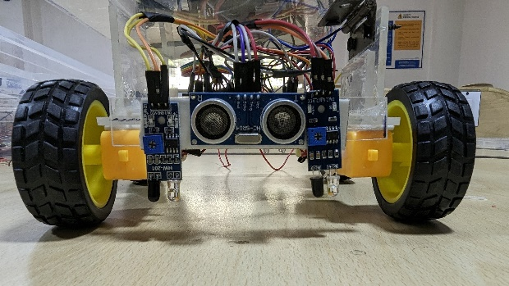

Figure 8 – NAVIGATION AND OBSTACLE DETECTION (IR AND ULTRASONIC SENSOR)

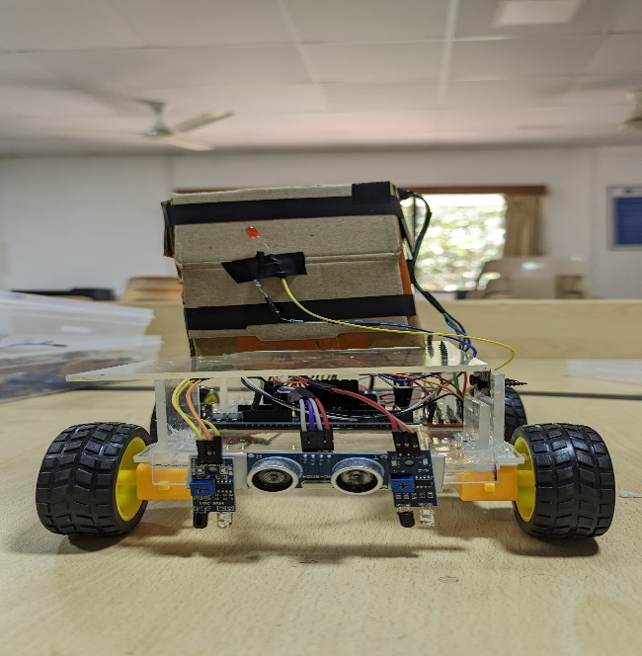

Figure 9 – LEVEL SENSING WITH UTRASONIC SENSOR AND LED INDICATOR

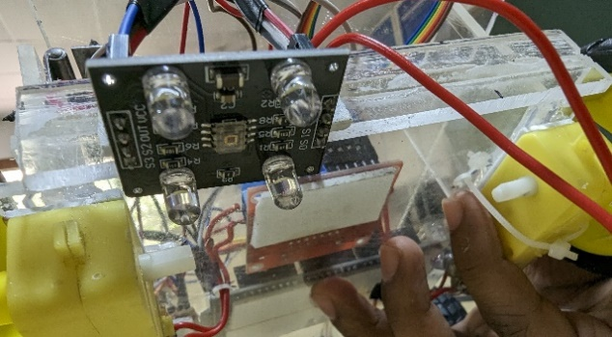

Figure 10 – COLOR SENSOR TO DETECT ILLUMINATION OF LED FIXED BENEATH THE STRUCTURE

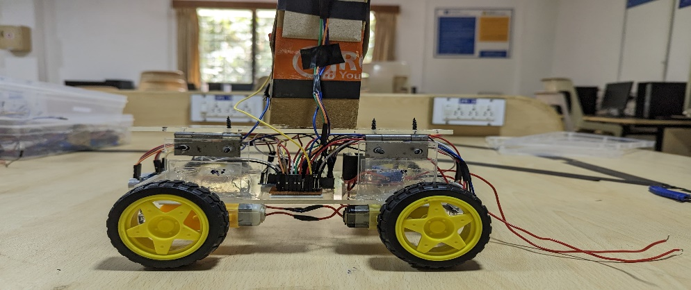

Figure 11 – FULL STRUCTURAL VIEW

##### ACKNOWLEDGEMENT

We, the team members, Mithilesh K, Hari Krishna N, Rakesh V and Pubesh Kumaar KS extend our heartfelt thanks to Dr.Appu R Paduthol for his invaluable guidance and mentorship throughout course of our project.

We also extend our gratitude to faculty and staff members of Department of Electronics and Communication of Amrita Vishwa Vidyapeetham for the providing the necessary facilities and conductive environment for the work. Special thanks to Dr.Kirthiga S for her helpful feedback and advice.

Special thanks to Lab staff Ms.Anitha K for her invaluable help in providing of various components and in ensuring accessibility to laboratory which were crucial for completion of project within prescribed deadline.

##### References

1. S. K. Ghosh, S. S. Ahmed, R. S. Meshram, G. V., and S. Salvi, "Fully Automated Waste Management System Using Line Follower Robot," in *Emerging Research in Computing, Information, Communication and Applications*, National Institute of Technology Karnataka, Surathkal, Karnataka, India (2022)
2. Raja, Prasana, C. Janani and Annes Thivya. “GARBAGE MONITORING AND CLEARANCE USING ROBOTS.” (2020).
3. Pratheepkumar, V, Kshitij Prabha and Kumaraguru Prabakar. “A real-time autonomous waste-collecting robot.” International Journal of Advance Research, Ideas and Innovations in Technology 6 (2020): 287-289.